Lab 4

- Determine whether Insertion Sort, Bubble Sort, Selection Sort are stable sorting algorithms, and in each case, explain your answer.
Solution:

A sorting algorithm is said to be stable if two objects with equal keys appears in the same order in sorted output as they appear in the input unsorted array.
Generally, Insertion sort and bubble sort are stable as they don’t change the sequence of the repetitive elements even after sorting. But Selection sort in not stable sorting as it changes it doesn’t maintain the previous sequence.
Lets in Case of Bubble Sort if we have 3 elements like
(3,x),(3,y),(2,z)
Even after first Iteration of the outerloop it becomes
(3,x), (2,z),(3,y)
So its clear that still after sorting some phase it maintain the order of the repetitive elements. So we can say that its stable.

Now in case of Selection Sort lets consider the same example.
(3,x),(3,y),(2,z)
After the First for loop , it becomes
(3,y),(2,z), (3,x)
So now in this case the sequence of two elements (3,x) and (3,y) are changed so we can say that its not stable.
Similarly Insertion sort is also stable as like Bubble sort.
(3,x),(3,y),(2,z)
I = 1 : (3,x),(3,y),(2,z)
I = 2 : (2,z), (3,x),(3,y)

- Perform the MergeSort algorithm by hand on the array [7, 6, 5, 4, 3, 2, 1]. Show all
steps.
Solution:

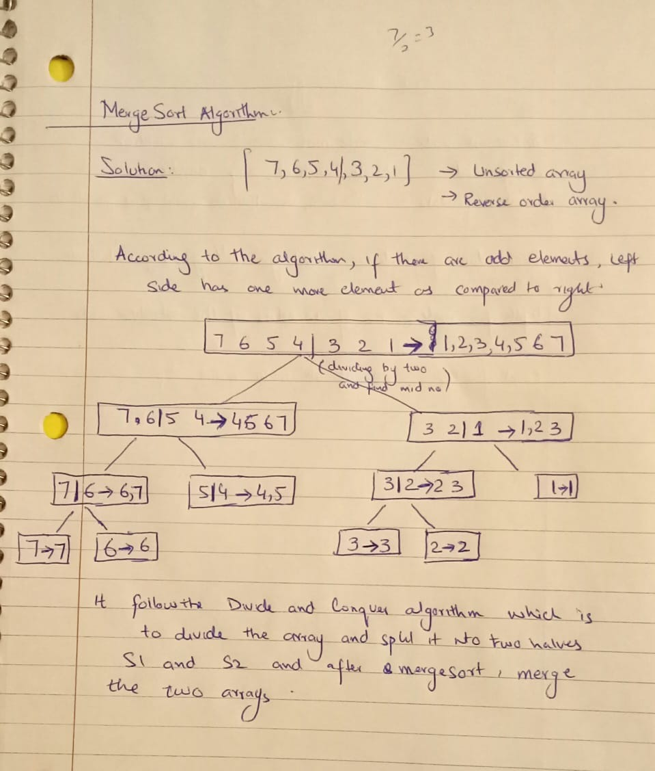

- Sometimes MergeSort is supplemented with a secondary sorting routine (typically, InsertionSort is used) in the following way: During the recursion in MergeSort, the size of the array being sorted becomes smaller and smaller. To create a hybrid sorting routine, when a recursive call requires the algorithm to process an array with 20 or fewer elements, give this array to InsertionSort and patch in the result after it has finished. Call this hybrid algorithm MergeSortPlus.

  - Express the steps of MergeSortPlus in the pseudo-code language we are using in class.

  - Write the Java code for MergeSortPlus (use the implementation of MergeSort provided in the lab folder)

  - Run tests to compare running times of MergeSort and MergeSortPlus. Which one runs faster? Explain how you tested and whether you feel your results are conclusive.

Solution:

If(lower==upper) then
Return
If(upper-lower<=20) then
Insertionsort(lower,upper)
[else]
mid←(lower+upper)/2
mergeSort(tempstorage,lower,mid)
mergeSort(tempstorage,mid+1,upper)
merge(tempStorage,lower,mid+1,upper)
B) For the java Code see the attached file.

C) Merge sort Plus is more faster than merge sort and the results are more conclusive as in cases of array with size less than 20 , Insertion sort is more faster than Merge sort.

- Binary Trees. A binary tree is a tree in which every node has at most two children.

- Write out 4 different binary trees, each having height = 3 – make sure that no two of your trees have the same number of nodes. (There is no need to give labels to the nodes.

- Examine the trees you have drawn and decide whether the following statement is true or false:

Every binary tree of height 3 has at most 2³=8 leaves.

- Based on your answer to b, what do you think is true in general about the number of leaves of a binary tree of height n?
Solution:
